17th October 2019

Dear Parent/Carer

I am writing to inform you of some slight changes to our morning routine. This will start on Monday 21st October.

Breakfast Club:
Children can arrive at Breakfast club from 7.40am until 8.30am. It is free of charge and available for school age children (Reception to Year 6.) Please sign in at the front office.

Pre-School (Butterflies and Fox Cubs):

Arrangements remain the same and the doors will be open from 8.30am until 9am so that you can drop the children off when it suits you best.

Reception (Hedgehogs):

Doors open at 8.45am. Parents are welcome to come into the classroom but we would like all children to be coming in by themselves by the Easter holidays to prepare them for Key Stage One. It is useful if parents leave the classroom as soon as they can so we can start the school day and get ready for Assembly.

Year 1 to 6:

Doors to all classrooms will now be open from 8.45am until 9am. This will mean children and parents do not need to wait in the cold and rain and can also drop their children off in an order that suits them best. Teachers will be available on classroom doors for the 15 minutes so that important messages can be passed on. Children will have a morning task to complete before Assembly. For safeguarding reasons, please can we ask that parents do not enter the classrooms at this time.

Kind Regards

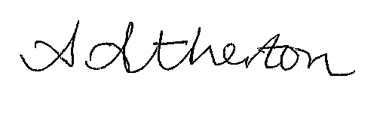

Mrs A Atherton
Head teacher
Burton Green Primary School

