**Key Stage 1 Curriculum Overview 2018-2020**

**Cycle A:**



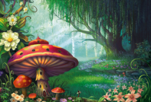

**Autumn Term – Under the Sea**

**Spring Term – Victorian Britain**

**Summer Term – Enchanted Forest**

**Cycle B:**

