**Useful Websites for Fox Cubs**

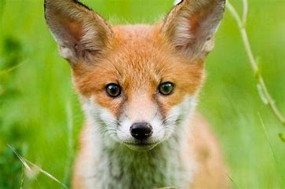

**Phonics/Listening to Sounds**

<https://www.phonicsplay.co.uk/BuriedTreasure2.html>

**Mix of Activities and Resources**

<https://www.sesamestreet.org/>

<https://www.tts-group.co.uk/home+learning+activities.html>

<https://www.twinkl.co.uk>

<https://www.crickweb.co.uk/Early-Years.html>

**Maths**

[**https://nrich.maths.org/13371**](https://nrich.maths.org/13371)

<https://www.topmarks.co.uk/Search.aspx?subject=37>

**Knowledge and Understanding of the World**

<https://www.bigeyedowl.co.uk/science/water-activities.htm>

**Songs and Rhymes**

<https://learnenglishkids.britishcouncil.org/songs>