Foxes- Y5/6
Maths
Keep practising your maths skills while you are at home. Remember that if you want to keep a skill, you have to practise it regularly. You can do the maths that has been sent home for you or you could make up your own questions. If you have younger siblings, you could be the teacher and make questions up for them.
TTRockstars  Try to spend at least ten minutes each day on TTR. By the time we come back to school, you could all be Rock Gods! |  |  |  | Corbett Maths  You have a pack of Corbett Maths to keep you busy, but you can find more and print them from https://corbettmaths primary.com/5-a-day/ | Maths challenges  -Can you learn to tell the time?  -Can you follow a recipe to bake something tasty?  -Can you make a board game and play it with your family?
Writing ideas
- Keep a diary about the events going on around us- you could be like the next Samuel Pepys!
- Write a scary story- it could be inspired by current events or it could be entirely fictional
- Make up a character, describe them and their world
- Find out about a country or culture different to ours, see if you can produce a project on them
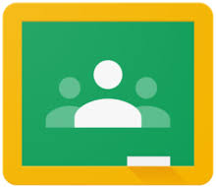
- Write a film review to recommend something to your friends, remember to share it with them.

You can share any work that you are proud of with me on Google Classroom, I promise to look at least once a day. Just log on as we would usually!

Reading |  | Keeping busy even when you might be a bit bored…
Please continue to read EVERYDAY for at least 10 minutes.  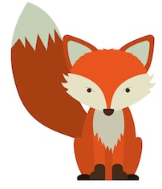  You could even have new books delivered to your house! |  | - Build a blanket fort and eat snacks in it  - Phone or FaceTime an elderly relative or person in our community- make them smile!  - Learn a new skill- YouTube is great for learning how to do things step by step  - Cook from a recipe that you’ve never used before  - Make a video that will spread happiness  - Help out at home, show the adults in your life how responsible you can be  - Make up a new game and play it with your family  - Do a jigsaw or some mindfulness colouring  - Take on an art project, make something that you can be proud of!  If you want to share pictures of what you’ve been up to, you could on our class Twitter page @BG_Foxes
Below are also some websites that you could use at home.
Maths  https://www.topmarks.co.uk/  https://mathsframe.co.uk/  https://play.ttrockstars.com  Online quizzes  https://quizizz.com/  https://www.lbq.org/ |  |  | Writing  http://www.pobble365.com/  https://www.j2e.com/jit5#  https://www.ictgames.com/  https://spellingframe.co.uk/ https://www.bbc.co.uk/bitesize |  | https://www.twinkl.co.uk/ - a huge range of different subjects and focuses, arguably the best host of any resource you could need. Have offered a free account in the result of school closures.

