Hares
Maths
Whilst at home please continue practicing your basic arithmetic skills. Challenge yourself by comparing number sentences or rolling a dice to create your own questions. Below are some examples of how you would show your working out!
23 + 14 =  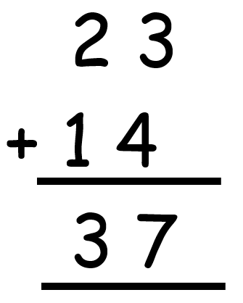  48 + 35 =  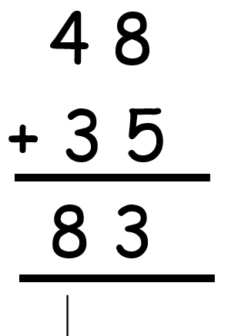 | 78 – 36 =  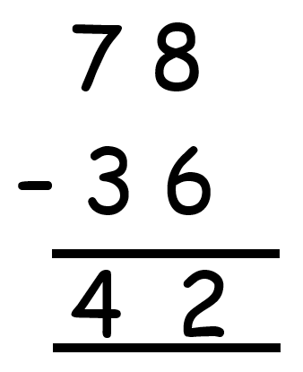  63 – 46 =  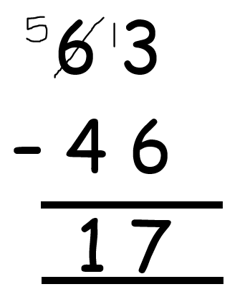 |  | 7 X 2 =  Hold up seven fingers and count in twos!  3 X 8 =  Don’t know your 8s? Hold up eight fingers and count in threes!  18 ÷ 3 =  Count in 3s until you say 18! | ¼ of 12 is 3  2/3 of 21 is 14  Bottom number = circles to draw  Biggest number = number to share  Top number = circles to count
CHALLENGE!
- Can you learn to tell the time on an analogue clock?
- Can you use the correct change to buy something under £1 at the shop?
- How many different 2D and 3D shapes you can find around the house?
- Can you follow a recipe and weigh out all your own ingredients?

Writing ideas | Reading |  | Fun at home! How many of these activities can you tick off?
You could…  Write a diary about what you did whilst you weren’t at school.  Retell one of your favourite stories but change the main characters and how it ends.  Bake something and write your own instructions. | Please continue to read EVERYDAY for at least 10 minutes.  Use the app or find Epic Reading online for plenty of free books.  Code: dtd3347 |  | - Build a den.  - Make up a dance.  - Make a puppet from an old sock.  - Create your own board game.  - Write a song or rap.  - Draw or paint a picture.  - Write and perform a play.  - Create a treasure map around your house.  - Plant some flowers.  - Cook with a food you have never tried before.  - Have a paper plane competition.  - Learn a magic trick.  - Create a time capsule.
Below are also some websites that you could use at home.
Maths  https://www.topmarks.co.uk/  https://mathsframe.co.uk/  Phonics and spelling  https://www.phonicsbloom.com/  https://spellingframe.co.uk/ |  | Writing  http://www.pobble365.com/  https://www.j2e.com/jit5#  https://www.ictgames.com/  Online quizzes  https://quizizz.com/ |  | https://www.twinkl.co.uk/ - a huge range of different subjects and focuses, arguably the best host of any resource you could need. Have offered a free account in the result of school closures.

