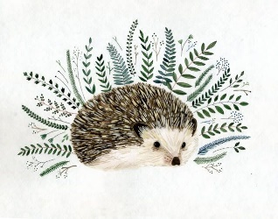
My Home Learning Passport
How many can you complete? Give each one a tick when you’ve completed it.
Reading
Keep reading and writing in your reading records!
You can still use Bug Club from home! Download the app or log into the website: www.activelearnprimary.co.uk
Username: child’s name Password: hedgehogs School: L63r

Apps for learning
- Phonics Bloom - free online phonics games phase 2-5.
www.phonicsbloom.com
- Topmarks – free maths games for all ages
www.topmarks.co.uk/
- Twinkl - a huge range of different subjects and focuses, have offered a free account in the result of school closures
www.twinkl.co.uk
- Phonics Play – the app we use in phonics lessons – now free for home learning in this time
www.phonicsplay.co.uk
Username: march20
Password: home

Party Games
- Musical Bumps
- Musical Statues
- Simon Says
- Dance party
- Sleeping Lions
- Karaoke
Educational Episodes
- CBeebies Bedtime Stories on CBeebies/BBC iPlayer
- Numberblocks episodes and songs on YouTube or CBeebies/BBC iPlayer

Nature Walk
Go in your garden or for a walk in a big open space and see what you can find in nature.

Junk Modelling
Use different pieces of recycling to make towers and models.

Eye Spy
Play a game of eye spy and make a list of everything you spied.

Shape Hunt
Go on a shape hunt around your home. How many 2D and 3D shapes will you find?
Circles Cuboid
Squares Cube
Rectangles Sphere
Triangles Cylinder

Workout
Complete a mini workout:
- Do 10 star jumps
- Walk on your tip toes for 2 minutes.
- Jog on the spot for 2 minutes
- Joe Wicks 5 minute workouts on YouTube
- Cosmic Kids Yoga episodes on YouTube

