18th September 2020

Dear Parent/Carer

Vale of York Academy will be holding a Virtual Open Evening on Thursday 1st October. The Virtual Open Evening will consist of a series of Zoom presentations between 18.00 and 20.00 and will give families the opportunity to meet and listen to Vale of York Principal Toby Eastaugh. Included in the presentation will be information about the school, their vision moving forwards and why Vale of York Academy would be an excellent choice for your child's secondary education. Due to the nature of the event, the presentations have unfortunately had to be limited to 20 minutes to ensure families from all primary schools are able to engage with the Virtual Open Evening. Further information relating to the Open Evening however will be on the Vale of York website in due course. The website can be found at www.valeofyorkacademy.org.

The information required for Burton Green allocated slot is:

TIME: 19.40 - 20.00
MEETING ID: 848 5768 5907
PASSCODE: 839213

In addition to the Virtual Open Evening, Vale of York's Transition Coordinator Rob Orr will be holding an information stall at Burton Green on Monday 28th September between 15.00 and 15.30. This is your chance to find out about Vale of York Academy's prospectus, ask Rob any questions you have about the school and also the transition process from this point forward. His email address is r.orr@voy.hlt.academy so please don't hesitate to get in touch with him if there is anything you would like to ask beforehand and for further information about the Virtual Open Evening.

Thank you

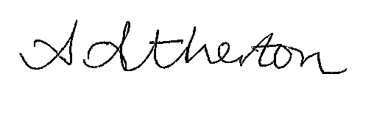

Mrs Atherton
Headteacher

