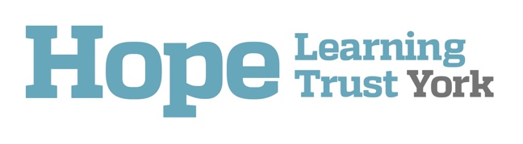

Addendum to
School Behaviour Policy/Code of Conduct

Document Management:
Date of last review: 28th September 2020

Signed by:
 | Chief Executive Officer | Date:
 | Chair of the Trust Board | Date:

Context
This addendum is for use as part of the arrangements for education of pupils in school during the Covid-19 period. It is to be used in conjunction with, and read alongside, the school Anti-Bullying, Safeguarding and Child Protection policies.
Schools must be mindful how mental health and wellbeing issues can bring about changes in a young person’s behaviour or emotional state. Students with the most challenging behaviour may need a more targeted approach to their learning and to pastoral support. With regards to any decision made, the safety and welfare of all staff and students is paramount.

Behaviour policy/Code of Conduct
- Schools to have altered routines for arrival and departure.
- Clear instructions on hygiene, such as handwashing and sanitising.
- Clear instructions on the wearing of face coverings for pupils over the age of 12 which is essential in indoor communal areas where social distancing cannot be safely managed.
- Clear instructions to pupils about how to put on, remove, store and dispose of face coverings, to avoid inadvertently increasing the risks of transmission.
- Instructions on who pupils can socialise with, whilst at school.
- Moving around the school as per specific instructions (for example, one-way systems, out-of-bounds areas, queuing).
- Expectations about sneezing, coughing, tissues and disposal (in line with the "catch it, bin it, kill it" message) and avoiding touching your mouth, nose and eyes.
- Clear guidelines as to how pupils should report to members of staff, if they are experiencing symptoms of coronavirus whilst on site.
- Clear rules about sharing any equipment or other items, including drinking bottles.
- Amended expectations about breaks or play times, including where pupils may or may not play.
- Use of toilets at this time.
- Clear rules about coughing or spitting at or towards any other person.
- Clear rules for pupils at home about conduct in relation to remote education.
- Rewards and sanction systems, where appropriate.

New routines, habits and norms are clearly communicated with staff, students and parents.

High risk pupils
For children and young people with SEND, it is especially important to teach new norms and routines around protective measures and personal hygiene, clearly and accessibly.
Many pupils, especially the youngest children, may be lacking good hygiene habits/routines which could be dangerous in the current climate, if not challenged. Hygiene education must be the priority for schools reopening and expectations should be clearly communicated to staff, students and parents.
Risk assessments should be undertaken for those pupils who regularly display behaviours which could be classed as unsafe, for example biting and spitting, in order for schools to make a decision regarding access arrangements to schooling.

Consequences for pupils who choose not to follow the Behaviour Policy/ Covid-19 Code of Conduct
It must be made clear to pupils that if they do not follow the amended Behaviour Policy/Code of Conduct, parents/carers will be contacted and pupils will be sent home to protect their personal safety and that of other pupils and staff.
Malicious acts of transmission including coughing and spitting at or towards any other pupil or member of staff, will be classified as a serious incident, and the school’s Behaviour Policy must be followed as a consequence, which will result in a minimum fixed-term exclusion. The disciplinary powers that schools currently have, including exclusion, still remain in place.

