7th October 2020

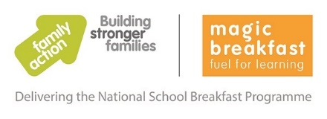

National School Breakfast Programme Covid response

Our school has signed up to receive free healthy breakfast food as part of the Covid response offer, under the National School Breakfast Programme (NSBP), which is being delivered by the charities Family Action and Magic Breakfast. The benefits of a healthy breakfast include children being settled and ready to learn at the start of the day.

As part of this government funded programme, schools can choose to offer children a healthy breakfast at school.

We will be offering children toasted bagels and some fruit at the beginning of the school day, when they enter their classroom in the morning, between 8.45am and 9am. We plan to start this on Monday 12th October 2020.

If you do not wish your child to have some bagel please contact the school.

