25/3/21

Dear All

Let's hope that everyone stays safe and well during the Half term Holidays.

However, if required, here is some information and relevant arrangements regarding any positive Covid 19 tests during the holidays.

- If your child develops coronavirus symptoms within two days of being in school and then tests positive, please email the school (hello@bgp.hlt.academy).

- This means that if your child was in school on Thursday 25th March and develops symptoms before the afternoon of Saturday 27th, and then tests positive, you would need to email the school.

- If a child or staff member tests positive in this timeframe, the relevant families will be contacted and the children asked to self-isolate.

Yours sincerely,

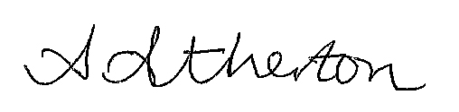

Ash Atherton
Executive Headteacher | Burton Green Primary School

