8th June 2021

Dear Parent/Carer,

I hope that you have had a good half term break. It is lovely to see the children looking so refreshed after a week in the sun. I am writing to update you on our plans for parent’s evenings this term.

Unfortunately, we are not able to offer face to face parent evenings as we usually would at this time of year. During the week commencing 14th June, you will receive a telephone call from your child’s class teacher. This will be an opportunity to discuss your child’s progress and attainment, especially since the full re-opening of schools on the 8th March. If this not a convenient time, please do not answer and your child’s teacher will try again at another point during the week. These calls will last approximately five to ten minutes and will give you the opportunity to ask any questions.

We will show you your child’s books as soon as the guidance allows this to happen. You will also receive an End of Year Report on 16th July.

Yours sincerely,

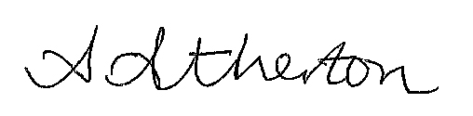

Ash Atherton
Head Teacher

